Case 3-Syro Hittite-Female Votive Figure-White Terra Cotta-2500 BCE

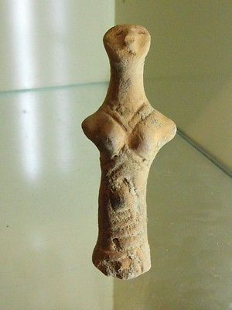

#### [RARE NEOLITHIC CLAY IDOL](http://www.ebay.com/itm/231815194921)

|  |  |
| --- | --- |
| Item price | $177.50 |
| Quantity | 1 |
| Item number | 231815194921 |
| Shipping service | Standard Shipping from outside US |